EXP. NO: 17
PERFORMANCE EVALUATION OF DIGITAL COMMUNICATION DATE: SYSTEMS USING EYE DIAGRAM ANALYSIS UNDER ADDITIVE WHITE GAUSSIAN NOISE (AWGN) USING MATLAB
Objectives :
1. To generate a digital communication signal in MATLAB and transmit it through an Additive White Gaussian Noise (AWGN) channel.
2. To obtain and analyze the eye diagram of the received digital signal for different noise conditions.
3. To measure eye-opening parameters such as eye height, eye width, crossing level and timing variation.
4. To study the effect of decreasing SNR / Eb/N0 on inter-symbol interference, noise margin and timing performance.
5. To compare the transmitted and received signal characteristics and evaluate communication-system performance.
Procedure :
1. Open MATLAB and create a new script file.
2. Set the number of bits/symbols, samples per symbol, modulation scheme, symbol rate and sampling parameters.
3. Generate a random binary sequence and map it to a digital waveform. For a basic experiment, use BPSK with symbols −1 and +1.
4. Generate the transmitted waveform using an appropriate pulse-shaping method or rectangular NRZ pulses.
5. Pass the waveform through an AWGN channel. Repeat the experiment for several SNR/Eb/N0 values, such as 20 dB, 10 dB, 5 dB and 0 dB.
6. Plot a portion of the transmitted and received waveforms in the time domain.
7. Construct the eye diagram by superimposing overlapping signal segments over two symbol periods.
8. Measure or estimate eye height, eye width, crossing level and timing uncertainty from the eye diagram.
9. Compare the eye diagrams for different noise levels and observe the reduction in vertical and horizontal eye opening.
10. Relate the observed eye-pattern changes to noise margin, sampling-time tolerance and probability of symbol decision errors.
11. Record the results and calculate percentage deviation/error where a theoretical reference is available.
PROGRAM :
clc;
clear;
close all;
%% Parameters
N = 100; % Number of bits
sps = 20; % Samples per symbol
SNR = 10; % Signal-to-Noise Ratio (dB)
%% Generate Random Binary Data
data = randi([0 1],1,N);
%% NRZ Encoding (0 -> 0, 1 -> 1)
tx_signal = repelem(data,sps);
%% Pass Signal through AWGN Channel
rx_signal = awgn(tx_signal,SNR,'measured');
%% Time Axis
t = (0:length(tx_signal)-1)/sps;
%% Plot Results
figure;
% Original Binary Data
subplot(4,1,1)
stairs(data,'LineWidth',1.5)
grid on
title('Original Binary Data')
xlabel('Bit Number')
ylabel('Bit')
ylim([-0.2 1.2])
% Transmitted NRZ Signal
subplot(4,1,2)
plot(t,tx_signal,'LineWidth',1.5)
grid on
title('Transmitted NRZ Signal')
xlabel('Time')
ylabel('Amplitude')
ylim([-0.5 1.5])
% Received Signal after AWGN
subplot(4,1,3)
plot(t,rx_signal,'r')
grid on
title(['Received Signal with AWGN (SNR = ',num2str(SNR),' dB)'])
xlabel('Time')
ylabel('Amplitude')
% Eye Diagram
subplot(4,1,4)
eyediagram(rx_signal,2*sps)
title('Eye Diagram of Received Signal')
Output:
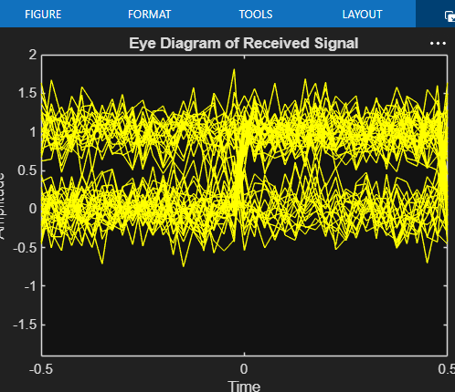
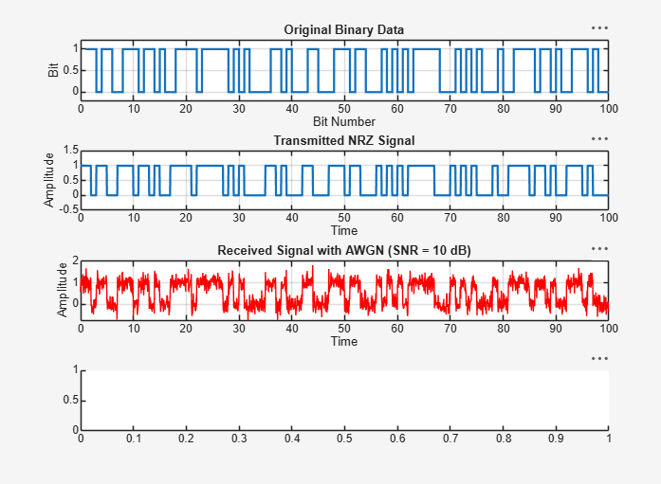
Result:
- Successfully generated an NRZ digital communication signal and transmitted it through an AWGN channel.
- Observed that the received signal was affected by Gaussian noise, resulting in signal distortion and bit errors.
- Successfully plotted the eye diagram of the received signal using MATLAB.
- Observed that the eye opening decreased due to AWGN, indicating reduced signal quality and increased probability of bit errors.

